|  |
| --- |
| **city university** |
| Data Structure |
| C-program |
|  |
|  |
| **11/1/2018** |

**Submitted by Submitted to**

Farjana Afroze Sanjida Richard Philip

ID : 171442519 Senior Lecturer

Batch : 44 Department of CSE

Department of CSE City University

|  |
| --- |
|  |

Table of Contents

Array 4

There are 2 types of C arrays. They are, 5

1.Single Dimensional Array : 5

Syntax : 5

Example of Single Dimensional Array : 5

Syntax : 5

Complexity 6

Calculating Time Complexity 7

Space Complexity of Algorithms 9

Stack 11

Algorithm for PUSH operation 12

Algorithm for POP operation 12

Analysis of Stack Operations 13

Queue 14

Implementation of Queue Data Structure 15

Algorithm for ENQUEUE operation 16

Link-List 17

Types of Linked List 17

Simple Linked List 18

Basic Operations 18

Doubly Linked List 20

Doubly Linked List Representation 20

Tree 21

Tree Node 23

BST Basic Operations 23

Insert Operation 24

Implementation 25

Search Operation 26

Algorithm 26

Traversal process 28

In-order Traversal 29

Algorithm 29

Pre-order Traversal 30

Algorithm 30

Post-order Traversal 31

Algorithm 31

Breadth First Search(BFS) 32

Traversing child nodes 32

Depth First Search (DFS) 34

Depth First Search (DFS) in Array 37

Depth First Search (DFS) in link list 38

Sorting 40

Increasing Order 42

Decreasing Order 42

Non-Increasing Order 42

Non-Decreasing Order 42

How Bubble Sort Works? 43

References: 46

Array

In C language, arrays are referred to as structured data types. An array is defined as **finite ordered collection of homogenous** data, stored in contiguous memory locations.

Here the words,

* **finite** means data range must be defined.
* **ordered** means data must be stored in continuous memory addresses.
* **homogenous** means data must be of similar data type.

Example where arrays are used,

* to store list of Employee or Student names,
* to store marks of students,
* or to store list of numbers or characters etc.

Declaring an Array,

Like any other variable, arrays must be declared before they are used. General form of array declaration is,

int arr[10];

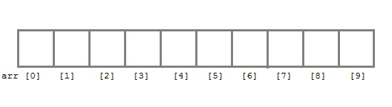

Here int is the data type, arr is the name of the array and 10 is the size of array. It means array arr can only contain 10 elements of int type.**Index** of an array starts from 0 to **size-1** i.e first element of arr array will be stored at arr[0] address and the last element will occupy arr[9].

. (Studytonight, 2015)

Types of arrays:

### **There are 2 types of C arrays. They are,**

1. One dimensional array
2. Multi dimensional array
   * Two dimensional array
   * Three dimensional array
   * four dimensional array etc…

1.Single Dimensional Array :

1. Single or One Dimensional array is used to represent and store data in a linear form.
2. Array having only one subscript variable is called **One-Dimensional array**
3. It is also called as **Single Dimensional Array** or **Linear Array**

### Syntax :

<data-type> <array_name> [size];

### Example of Single Dimensional Array :

**int** iarr[3] = {2, 3, 4};

**char** carr[20] = "c4learn" ;

**float** farr[3] = {12.5,13.5,14.5}

2. Multi Dimensional Array :

1.Array having more than one subscript variable is called [Multi-Dimensional array](http://www.c4learn.com/c-programming/c-multidimensional-array/).

2.Multi Dimensional Array is also called as **Matrix**.

### Syntax :

<data-type> <array_name> [row_subscript][column-subscript];

Example : Two Dimensional Array

**int a[3][3];**

**int** a[3][3] = { 1,2,3

5,6,7

8,9,0 }; (c4learn, 2013)

Complexity

Every algorithm requires some amount of computer time and space to execute its instruction to perform the task. This computer time required is called time complexity.

Time Complexity of Algorithms

For any defined problem, there can be N number of solution. This is true in general. If I have a problem and I discuss about the problem with all of my friends, they will all suggest me different solutions. And I am the one who has to decide which solution is the best based on the circumstances.

Similarly for any problem which must be solved using a program, there can be infinite number of solutions. Let's take a simple example to understand this. Below we have two different algorithms to find square of a number(for some time, forget that square of any number n is n*n):

One solution to this problem can be, running a loop for n times, starting with the number n and adding n to it, every time.

/*

we have to calculate the square of n

*/

for i=1 to n

do n = n + n

// when the loop ends n will hold its square

return n

Or, we can simply use a mathematical operator * to find the square.

/*

we have to calculate the square of n

*/

return n*n

In the above two simple algorithms, you saw how a single problem can have many solutions. While the first solution required a loop which will execute for n number of times, the second solution used a mathematical operator * to return the result in one line. So which one is the better approach, of course the second one.

What is Time Complexity?

Time complexity of an algorithm signifies the total time required by the program to run till its completion.

The time complexity of algorithms is most commonly expressed using the **big O notation**. It's an asymptotic notation to represent the time complexity. We will study about it in detail in the next tutorial.

Time Complexity is most commonly estimated by counting the number of elementary steps performed by any algorithm to finish execution. Like in the example above, for the first code the loop will run n number of times, so the time complexity will be n atleast and as the value of n will increase the time taken will also increase. While for the second code, time complexity is constant, because it will never be dependent on the value of n, it will always give the result in 1 step.

And since the algorithm's performance may vary with different types of input data, hence for an algorithm we usually use the **worst-case Time complexity** of an algorithm because that is the maximum time taken for any input size.

Calculating Time Complexity

Now lets tap onto the next big topic related to Time complexity, which is How to Calculate Time Complexity. It becomes very confusing some times, but we will try to explain it in the simplest way.

Now the most common metric for calculating time complexity is Big O notation. This removes all constant factors so that the running time can be estimated in relation to **N**, as N approaches infinity. In general you can think of it like this :

statement;

Above we have a single statement. Its Time Complexity will be **Constant**. The running time of the statement will not change in relation to N.

for(i=0; i < N; i++)

{

statement;

}

The time complexity for the above algorithm will be **Linear**. The running time of the loop is directly proportional to N. When N doubles, so does the running time.

for(i=0; i < N; i++)

{

for(j=0; j < N;j++)

{

statement;

}

}

This time, the time complexity for the above code will be **Quadratic**. The running time of the two loops is proportional to the square of N. When N doubles, the running time increases by N * N.

while(low <= high)

{

mid = (low + high) / 2;

if (target < list[mid])

high = mid - 1;

else if (target > list[mid])

low = mid + 1;

else break;

}

This is an algorithm to break a set of numbers into halves, to search a particular field(we will study this in detail later). Now, this algorithm will have a **Logarithmic** Time Complexity. The running time of the algorithm is proportional to the number of times N can be divided by 2(N is high-low here). This is because the algorithm divides the working area in half with each iteration.

void quicksort(int list[], int left, int right)

{

int pivot = partition(list, left, right);

quicksort(list, left, pivot - 1);

quicksort(list, pivot + 1, right);

}

Taking the previous algorithm forward, above we have a small logic of Quick Sort(we will study this in detail later). Now in Quick Sort, we divide the list into halves every time, but we repeat the iteration N times(where N is the size of list). Hence time complexity will be **N*log( N )**. The running time consists of N loops (iterative or recursive) that are logarithmic, thus the algorithm is a combination of linear and logarithmic.

(Studytonight, 2015)

Space Complexity of Algorithms

Whenever a solution to a problem is written some memory is required to complete. For any algorithm memory may be used for the following:

1. Variables (This include the constant values, temporary values)
2. Program Instruction
3. Execution

**Space complexity** is the amount of memory used by the algorithm (including the input values to the algorithm) to execute and produce the result.

Sometime **Auxiliary Space** is confused with Space Complexity. But Auxiliary Space is the extra space or the temporary space used by the algorithm during it's execution.

**Space Complexity** = **Auxiliary Space + Input space**

Memory Usage while Execution

While executing, algorithm uses memory space for three reasons:

1. **Instruction Space**

It's the amount of memory used to save the compiled version of instructions.

1. **Environmental Stack**

Sometimes an algorithm(function) may be called inside another algorithm(function). In such a situation, the current variables are pushed onto the system stack, where they wait for further execution and then the call to the inside algorithm(function) is made.

For example, If a function A() calls function B() inside it, then all th variables of the function A() will get stored on the system stack temporarily, while the function B() is called and executed inside the funciton A().

1. **Data Space**

Amount of space used by the variables and constants.

But while calculating the **Space Complexity** of any algorithm, we usually consider only **Data Space** and we neglect the **Instruction Space** and **Environmental Stack**.

Calculating the Space Complexity

For calculating the space complexity, we need to know the value of memory used by different type of datatype variables, which generally varies for different operating systems, but the method for calculating the space complexity remains the same.

|  |  |
| --- | --- |
| **Type** | **Size** |
| bool, char, unsigned char, signed char, __int8 | 1 byte |
| __int16, short, unsigned short, wchar_t, __wchar_t | 2 bytes |
| float, __int32, int, unsigned int, long, unsigned long | 4 bytes |
| double, __int64, long double, long long | 8 bytes |

Now let's learn how to compute space complexity by taking a few examples:

{

int z = a + b + c;

return(z);

}

In the above expression, variables a, b, c and z are all integer types, hence they will take up 2 bytes each, so total memory requirement will be (8 + 2) = 10 bytes, this additional 2 bytes is for **return value**. And because this space requirement is fixed for the above example, hence it is called **Constant Space Complexity**.

Let's have another example, this time a bit complex one,

// n is the length of array a[]

int sum(int a[], int n)

{

int x = 0; // 2 bytes for x

for(int i = 0; i < n; i++) // 2 bytes for i

{

x = x + a[i];

}

return(x);

}

* In the above code, 2*n bytes of space is required for the array a[] elements.
* 2 bytes each for x, n, i and the return value.

(Studytonight, 2015)

Stack

**Stack** is an abstract data type with a bounded(predefined) capacity. It is a simple data structure that allows adding and removing elements in a particular order. Every time an element is added, it goes on the **top** of the stack and the only element that can be removed is the element that is at the top of the stack, just like a pile of objects.

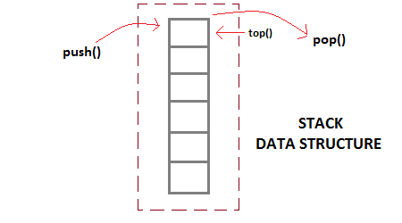

Basic features of Stack

1. Stack is an **ordered list** of **similar data type**.
2. Stack is a **LIFO**(Last in First out) structure or we can say **FILO**(First in Last out).
3. push() function is used to insert new elements into the Stack and pop() function is used to remove an element from the stack. Both insertion and removal are allowed at only one end of Stack called **Top**.
4. Stack is said to be in **Overflow** state when it is completely full and is said to be in **Underflow** state if it is completely empty.

Implementation of Stack Data Structure

Stack can be easily implemented using an Array or a Linked List. Arrays are quick, but are limited in size and Linked List requires overhead to allocate, link, unlink, and deallocate, but is not limited in size. Here we will implement Stack using array.

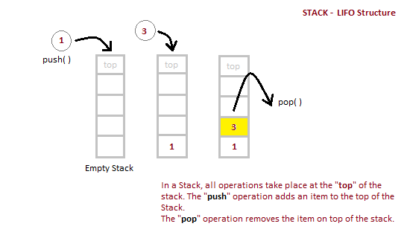

Algorithm for PUSH operation

1. Check if the stack is **full** or not.
2. If the stack is full, then print error of overflow and exit the program.
3. If the stack is not full, then increment the top and add the element.

Algorithm for POP operation

1. Check if the stack is empty or not.
2. If the stack is empty, then print error of underflow and exit the program.
3. If the stack is not empty, then print the element at the top and decrement the top.

Below we have a simple C++ program implementing stack data structure while following the object oriented programming concepts.

|  |  |
| --- | --- |
| **Position of Top** | **Status of Stack** |
| -1 | Stack is Empty |
| 0 | Only one element in Stack |
| N-1 | Stack is Full |
| N | Overflow state of Stack |

Analysis of Stack Operations

Below mentioned are the time complexities for various operations that can be performed on the Stack data structure.

* **Push Operation** : O(1)
* **Pop Operation** : O(1)
* **Top Operation** : O(1)
* **Search Operation** : O(n)

The time complexities for push() and pop() functions are O(1) because we always have to insert or remove the data from the **top** of the stack, which is a one step process.

(Studytonight, 2015)

Queue

**Queue** is also an abstract data type or a linear data structure, just like stack, in which the first element is inserted from one end called the **REAR**(also called **tail**), and the removal of existing element takes place from the other end called as **FRONT**(also called **head**).

This makes queue as **FIFO**(First in First Out) data structure, which means that element inserted first will be removed first.

Which is exactly how queue system works in real world. If you go to a ticket counter to buy movie tickets, and are first in the queue, then you will be the first one to get the tickets. Right? Same is the case with Queue data structure. Data inserted first, will leave the queue first.

The process to add an element into queue is called **Enqueue** and the process of removal of an element from queue is called **Dequeue**.

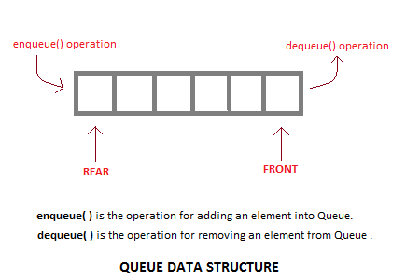

Basic features of Queue

1. Like stack, queue is also an ordered list of elements of similar data types.
2. Queue is a FIFO( First in First Out ) structure.
3. Once a new element is inserted into the Queue, all the elements inserted before the new element in the queue must be removed, to remove the new element.
4. peek( ) function is oftenly used to return the value of first element without dequeuing it.

Applications of Queue

Queue, as the name suggests is used whenever we need to manage any group of objects in an order in which the first one coming in, also gets out first while the others wait for their turn, like in the following scenarios:

1. Serving requests on a single shared resource, like a printer, CPU task scheduling etc.
2. In real life scenario, Call Center phone systems uses Queues to hold people calling them in an order, until a service representative is free.
3. Handling of interrupts in real-time systems. The interrupts are handled in the same order as they arrive i.e First come first served.

Implementation of Queue Data Structure

Queue can be implemented using an Array, Stack or Linked List. The easiest way of implementing a queue is by using an Array.

Initially the **head**(FRONT) and the **tail**(REAR) of the queue points at the first index of the array (starting the index of array from 0). As we add elements to the queue, the **tail** keeps on moving ahead, always pointing to the position where the next element will be inserted, while the **head** remains at the first index .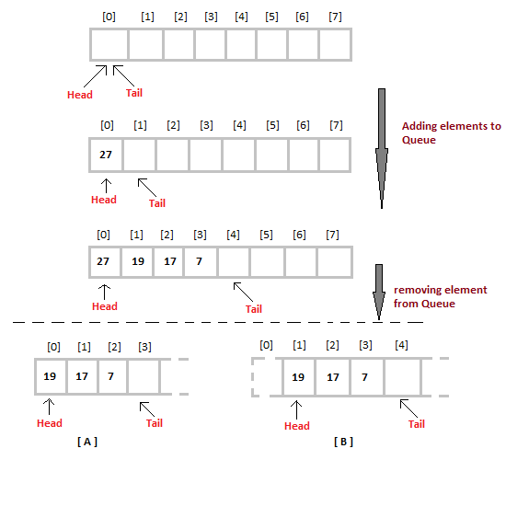

When we remove an element from Queue, we can follow two possible approaches (mentioned [A] and [B] in above diagram). In [A] approach, we remove the element at **head** position, and then one by one shift all the other elements in forward position.

In approach [B] we remove the element from **head** position and then move **head** to the next position.

In approach [A] there is an **overhead of shifting the elements one position forward** every time we remove the first element.

In approach [B] there is no such overhead, but whenever we move head one position ahead, after removal of first element, the **size on Queue is reduced by one space** each time.

Algorithm for ENQUEUE operation

1. Check if the queue is full or not.
2. If the queue is full, then print overflow error and exit the program.
3. If the queue is not full, then increment the tail and add the element.

Complexity Analysis of Queue Operations

Just like Stack, in case of a Queue too, we know exactly, on which position new element will be added and from where an element will be removed, hence both these operations requires a single step.

* Enqueue: **O(1)**
* Dequeue: **O(1)**
* Size: **O(1)**

(Studytonight, 2015)

Link-List

A linked list is a sequence of data structures, which are connected together via links.

Linked List is a sequence of links which contains items. Each link contains a connection to another link. Linked list is the second most-used data structure after array. Following are the important terms to understand the concept of Linked List.

* **Link** − Each link of a linked list can store a data called an element.
* **Next** − Each link of a linked list contains a link to the next link called Next.
* **LinkedList** − A Linked List contains the connection link to the first link called First.

Linked List Representation

Linked list can be visualized as a chain of nodes, where every node points to the next node.

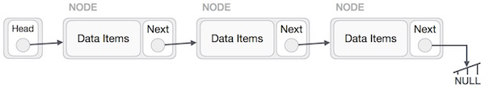

As per the above illustration, following are the important points to be considered.

* Linked List contains a link element called first.
* Each link carries a data field(s) and a link field called next.
* Each link is linked with its next link using its next link.
* Last link carries a link as null to mark the end of the list.

Types of Linked List

Following are the various types of linked list.

* **Simple Linked List** − Item navigation is forward only.
* **Doubly Linked List** − Items can be navigated forward and backward.
* **Circular Linked List** − Last item contains link of the first element as next and the first element has a link to the last element as previous.

Simple Linked List

# Basic Operations

Following are the basic operations supported by a list.

* **Insertion** − Adds an element at the beginning of the list.
* **Deletion** − Deletes an element at the beginning of the list.
* **Display** − Displays the complete list.
* **Search** − Searches an element using the given key.
* **Delete** − Deletes an element using the given key.

**Insertion Operation**

Adding a new node in linked list is a more than one step activity. We shall learn this with diagrams here. First, create a node using the same structure and find the location where it has to be inserted.

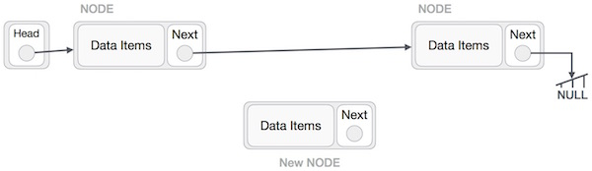

Imagine that we are inserting a node **B** (NewNode), between **A** (LeftNode) and **C** (RightNode). Then point B.next to C −

NewNode.next −> RightNode;

It should look like this −

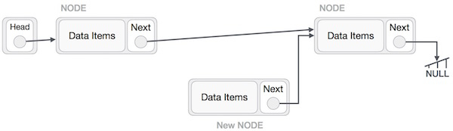

Now, the next node at the left should point to the new node.

LeftNode.next −> NewNode;

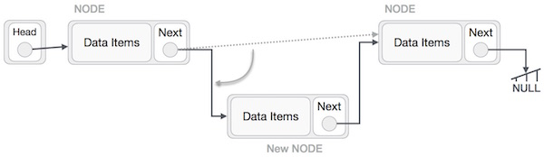

This will put the new node in the middle of the two. The new list should look like this −

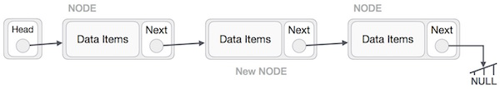

Similar steps should be taken if the node is being inserted at the beginning of the list. While inserting it at the end, the second last node of the list should point to the new node and the new node will point to NULL.

**Deletion Operation**

Deletion is also a more than one step process. We shall learn with pictorial representation. First, locate the target node to be removed, by using searching algorithms.

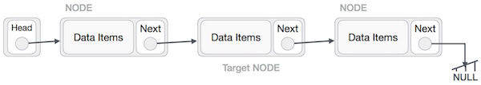

The left (previous) node of the target node now should point to the next node of the target node −

LeftNode.next −> TargetNode.next;

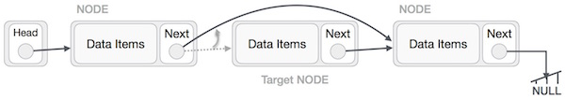

This will remove the link that was pointing to the target node. Now, using the following code, we will remove what the target node is pointing at.

TargetNode.next −> NULL;

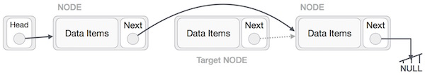

We need to use the deleted node. We can keep that in memory otherwise we can simply deallocate memory and wipe off the target node completely.

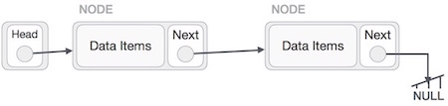

Doubly Linked List

Doubly Linked List is a variation of Linked list in which navigation is possible in both ways, either forward and backward easily as compared to Single Linked List. Following are the important terms to understand the concept of doubly linked list.

* **Link** − Each link of a linked list can store a data called an element.
* **Next** − Each link of a linked list contains a link to the next link called Next.
* **Prev** − Each link of a linked list contains a link to the previous link called Prev.
* **LinkedList** − A Linked List contains the connection link to the first link called First and to the last link called Last.

# Doubly Linked List Representation

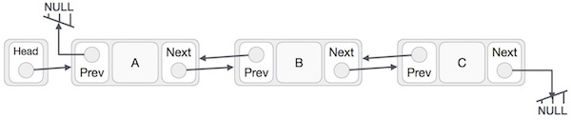

As per the above illustration, following are the important points to be considered.

* Doubly Linked List contains a link element called first and last.
* Each link carries a data field(s) and two link fields called next and prev.
* Each link is linked with its next link using its next link.
* Each link is linked with its previous link using its previous link.
* The last link carries a link as null to mark the end of the list.

**Basic Operations**

Following are the basic operations supported by a list.

* **Insertion** − Adds an element at the beginning of the list.
* **Deletion** − Deletes an element at the beginning of the list.
* **Insert Last** − Adds an element at the end of the list.
* **Delete Last** − Deletes an element from the end of the list.
* **Insert After** − Adds an element after an item of the list.
* **Delete** − Deletes an element from the list using the key.
* **Display forward** − Displays the complete list in a forward manner.
* **Display backward** − Displays the complete list in a backward manner.

Tree

Tree represents the nodes connected by edges. We will discuss binary tree or binary search tree specifically.

Binary Tree is a special datastructure used for data storage purposes. A binary tree has a special condition that each node can have a maximum of two children. A binary tree has the benefits of both an ordered array and a linked list as search is as quick as in a sorted array and insertion or deletion operation are as fast as in linked list.

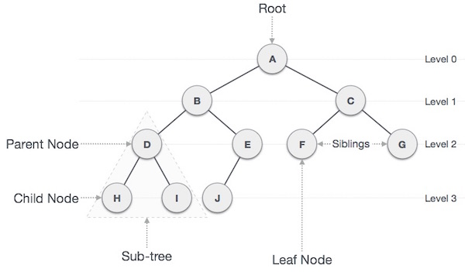

Important Terms

Following are the important terms with respect to tree.

* **Path** − Path refers to the sequence of nodes along the edges of a tree.
* **Root** − The node at the top of the tree is called root. There is only one root per tree and one path from the root node to any node.
* **Parent** − Any node except the root node has one edge upward to a node called parent.
* **Child** − The node below a given node connected by its edge downward is called its child node.
* **Leaf** − The node which does not have any child node is called the leaf node.
* **Subtree** − Subtree represents the descendants of a node.
* **Visiting** − Visiting refers to checking the value of a node when control is on the node.
* **Traversing** − Traversing means passing through nodes in a specific order.
* **Levels** − Level of a node represents the generation of a node. If the root node is at level 0, then its next child node is at level 1, its grandchild is at level 2, and so on.
* **keys** − Key represents a value of a node based on which a search operation is to be carried out for a node.

Binary Search Tree Representation

Binary Search tree exhibits a special behavior. A node's left child must have a value less than its parent's value and the node's right child must have a value greater than its parent value.

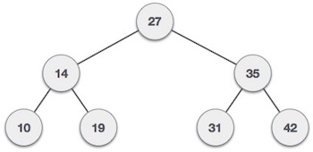

We're going to implement tree using node object and connecting them through references.

## Tree Node

The code to write a tree node would be similar to what is given below. It has a data part and references to its left and right child nodes.

struct node {

int data;

struct node *leftChild;

struct node *rightChild;

};

In a tree, all nodes share common construct.

BST Basic Operations

The basic operations that can be performed on a binary search tree data structure, are the following −

* **Insert** − Inserts an element in a tree/create a tree.
* **Search** − Searches an element in a tree.
* **Preorder Traversal** − Traverses a tree in a pre-order manner.
* **Inorder Traversal** − Traverses a tree in an in-order manner.
* **Postorder Traversal** − Traverses a tree in a post-order manner.

We shall learn creating (inserting into) a tree structure and searching a data item in a tree in this chapter. We shall learn about tree traversing methods in the coming chapter.

Insert Operation

The very first insertion creates the tree. Afterwards, whenever an element is to be inserted, first locate its proper location. Start searching from the root node, then if the data is less than the key value, search for the empty location in the left subtree and insert the data. Otherwise, search for the empty location in the right subtree and insert the data.

Algorithm

If root is NULL

then create root node

return

If root exists then

compare the data with node.data

while until insertion position is located

If data is greater than node.data

goto right subtree

else

goto left subtree

endwhile

insert data

end If

Implementation

The implementation of insert function should look like this −

void insert(int data) {

struct node *tempNode = (struct node*) malloc(sizeof(struct node));

struct node *current;

struct node *parent;

tempNode->data = data;

tempNode->leftChild = NULL;

tempNode->rightChild = NULL;

//if tree is empty, create root node

if(root == NULL) {

root = tempNode;

} else {

current = root;

parent = NULL;

while(1) {

parent = current;

//go to left of the tree

if(data < parent->data) {

current = current->leftChild;

//insert to the left

if(current == NULL) {

parent->leftChild = tempNode;

return;

}

}

//go to right of the tree

else {

current = current->rightChild;

//insert to the right

if(current == NULL) {

parent->rightChild = tempNode;

return;

}

}

}

}

}

Search Operation

Whenever an element is to be searched, start searching from the root node, then if the data is less than the key value, search for the element in the left subtree. Otherwise, search for the element in the right subtree. Follow the same algorithm for each node.

### Algorithm

If root.data is equal to search.data

return root

else

while data not found

If data is greater than node.data

goto right subtree

else

goto left subtree

If data found

return node

endwhile

return data not found

end if

The implementation of this algorithm should look like this.

struct node* search(int data) {

struct node *current = root;

printf("Visiting elements: ");

while(current->data != data) {

if(current != NULL)

printf("%d ",current->data);

//go to left tree

if(current->data > data) {

current = current->leftChild;

}

//else go to right tree

else {

current = current->rightChild;

}

//not found

if(current == NULL) {

return NULL;

}

return current;

}

}

Traversal process

Traversal is a process to visit all the nodes of a tree and may print their values too. Because, all nodes are connected via edges (links) we always start from the root (head) node. That is, we cannot randomly access a node in a tree. There are three ways which we use to traverse a tree −

* In-order Traversal
* Pre-order Traversal
* Post-order Traversal

Generally, we traverse a tree to search or locate a given item or key in the tree or to print all the values it contains.

In-order Traversal

In this traversal method, the left subtree is visited first, then the root and later the right sub-tree. We should always remember that every node may represent a subtree itself.

If a binary tree is traversed **in-order**, the output will produce sorted key values in an ascending order.

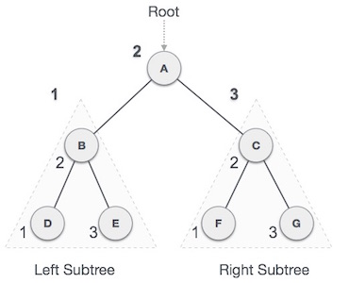

We start from **A**, and following in-order traversal, we move to its left subtree **B**. **B** is also traversed in-order. The process goes on until all the nodes are visited. The output of inorder traversal of this tree will be −

**D → B → E → A → F → C → G**

### Algorithm

Until all nodes are traversed −

**Step 1** − Recursively traverse left subtree.

**Step 2** − Visit root node.

**Step 3** − Recursively traverse right subtree.

Pre-order Traversal

In this traversal method, the root node is visited first, then the left subtree and finally the right subtree.

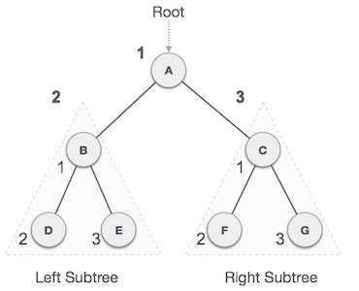

We start from **A**, and following pre-order traversal, we first visit **A** itself and then move to its left subtree **B**. **B** is also traversed pre-order. The process goes on until all the nodes are visited. The output of pre-order traversal of this tree will be −

**A → B → D → E → C → F → G**

### Algorithm

Until all nodes are traversed −

**Step 1** − Visit root node.

**Step 2** − Recursively traverse left subtree.

**Step 3** − Recursively traverse right subtree.

Post-order Traversal

In this traversal method, the root node is visited last, hence the name. First we traverse the left subtree, then the right subtree and finally the root node.

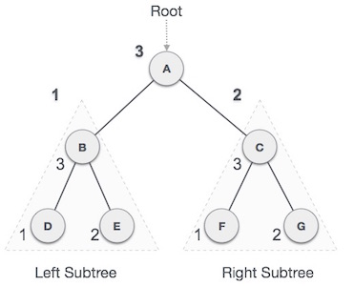

We start from **A**, and following Post-order traversal, we first visit the left subtree **B**. **B** is also traversed post-order. The process goes on until all the nodes are visited. The output of post-order traversal of this tree will be −

**D → E → B → F → G → C → A**

### Algorithm

Until all nodes are traversed −

**Step 1** − Recursively traverse left subtree.

**Step 2** − Recursively traverse right subtree.

**Step 3** − Visit root node.

(tutorialspoint, 2015)

Breadth First Search(BFS)

Graph traversals

Graph traversal means visiting every vertex and edge exactly once in a well-defined order. While using certain graph algorithms, you must ensure that each vertex of the graph is visited exactly once. The order in which the vertices are visited are important and may depend upon the algorithm or question that you are solving.

During a traversal, it is important that you track which vertices have been visited. The most common way of tracking vertices is to mark them.

Breadth First Search (BFS)

There are many ways to traverse graphs. BFS is the most commonly used approach.

BFS is a traversing algorithm where you should start traversing from a selected node (source or starting node) and traverse the graph layerwise thus exploring the neighbour nodes (nodes which are directly connected to source node). You must then move towards the next-level neighbour nodes.

As the name BFS suggests, you are required to traverse the graph breadthwise as follows:

1. First move horizontally and visit all the nodes of the current layer
2. Move to the next layer

Consider the following diagram.

The distance between the nodes in layer 1 is comparitively lesser than the distance between the nodes in layer 2. Therefore, in BFS, you must traverse all the nodes in layer 1 before you move to the nodes in layer 2.

## Traversing child nodes

A graph can contain cycles, which may bring you to the same node again while traversing the graph. To avoid processing of same node again, use a boolean array which marks the node after it is processed. While visiting the nodes in the layer of a graph, store them in a manner such that you can traverse the corresponding child nodes in a similar order.

In the earlier diagram, start traversing from 0 and visit its child nodes 1, 2, and 3. Store them in the order in which they are visited. This will allow you to visit the child nodes of 1 first (i.e. 4 and 5), then of 2 (i.e. 6 and 7), and then of 3 (i.e. 7) etc.

To make this process easy, use a queue to store the node and mark it as 'visited' until all its neighbours (vertices that are directly connected to it) are marked. The queue follows the First In First Out (FIFO) queuing method, and therefore, the neigbors of the node will be visited in the order in which they were inserted in the node i.e. the node that was inserted first will be visited first, and so on.

In this code, while you visit each node, the level of that node is set with an increment in the level of its parent node. This is how the level of each node is determined.

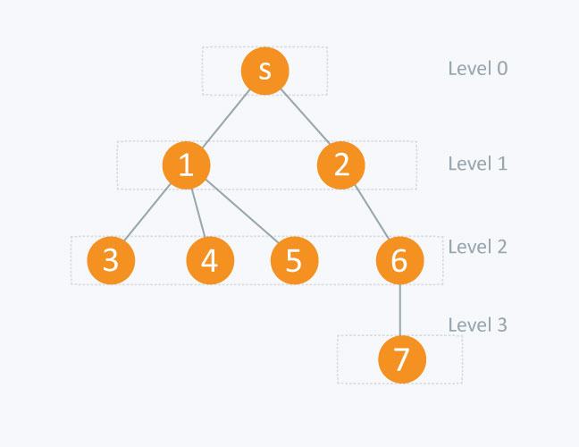

node level [node]

s (source node) 0

1 1

2 1

3 2

4 2

5 2

6 2

7 3

(hackerearth, 2016)

Depth First Search (DFS)

Depth First Search (DFS) algorithm traverses a graph in a depthward motion and uses a stack to remember to get the next vertex to start a search, when a dead end occurs in any iteration.

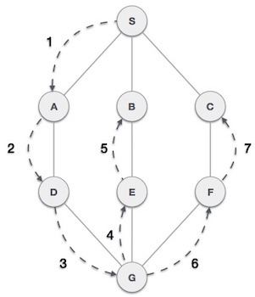

As in the example given above, DFS algorithm traverses from S to A to D to G to E to B first, then to F and lastly to C. It employs the following rules.

* **Rule 1** − Visit the adjacent unvisited vertex. Mark it as visited. Display it. Push it in a stack.
* **Rule 2** − If no adjacent vertex is found, pop up a vertex from the stack. (It will pop up all the vertices from the stack, which do not have adjacent vertices.)
* **Rule 3** − Repeat Rule 1 and Rule 2 until the stack is empty.

|  |  |  |
| --- | --- | --- |
| **Step** | **Traversal** | **Description** |
| 1 | Depth First Search Step One | Initialize the stack. |
| 2 | Depth First Search Step Two | Mark **S** as visited and put it onto the stack. Explore any unvisited adjacent node from **S**. We have three nodes and we can pick any of them. For this example, we shall take the node in an alphabetical order. |
| 3 | Depth First Search Step Three | Mark **A** as visited and put it onto the stack. Explore any unvisited adjacent node from A. Both **S**and **D** are adjacent to **A** but we are concerned for unvisited nodes only. |
| 4 | Depth First Search Step Four | Visit **D** and mark it as visited and put onto the stack. Here, we have **B** and **C** nodes, which are adjacent to **D** and both are unvisited. However, we shall again choose in an alphabetical order. |
| 5 | Depth First Search Step Five | We choose **B**, mark it as visited and put onto the stack. Here **B**does not have any unvisited adjacent node. So, we pop **B**from the stack. |
| 6 | Depth First Search Step Six | We check the stack top for return to the previous node and check if it has any unvisited nodes. Here, we find **D** to be on the top of the stack. |
| 7 | Depth First Search Step Seven | Only unvisited adjacent node is from **D** is **C** now. So we visit **C**, mark it as visited and put it onto the stack. |

As **C** does not have any unvisited adjacent node so we keep popping the stack until we find a node that has an unvisited adjacent node. In this case, there's none and we keep popping until the stack is empty.

(tutorialspoint, 2015)

Depth First Search (DFS) in Array

|  |  |
| --- | --- |
|  | #include<stdio.h>  void DFS(int);  int G[10][10],visited[10],n;    //n is no of vertices and graph is sorted in array G[10][10]    void main()  {      int i,j;      printf("Enter number of vertices:");        scanf("%d",&n);    //read the adjecency matrix      printf("\nEnter adjecency matrix of the graph:")      for(i=0;i<n;i++)         for(j=0;j<n;j++)              scanf("%d",&G[i][j]);        //visited is initialized to zero     for(i=0;i<n;i++)          visited[i]=0;  DFS(0);  }  void DFS(int i)  {      int j;      printf("\n%d",i);      visited[i]=1;       for(j=0;j<n;j++)         if(!visited[j]&&G[i][j]==1)              DFS(j);  } |

Depth First Search (DFS) in link list

#include<stdio.h>

#include<stdlib.h>

typedef struct node

{

    struct node *next;

    int vertex;

}node;

node *G[20];

//heads of linked list

int visited[20];

int n;

void read_graph();

//create adjacency list

void insert(int,int);

//insert an edge (vi,vj) in te adjacency list

void DFS(int);

void main()

{

    int i;

    read_graph();

    //initialised visited to 0

    for(i=0;i<n;i++)

        visited[i]=0;

    DFS(0);

}

void DFS(int i)

{

    node *p;

    printf("\n%d",i);

    p=G[i];

    visited[i]=1;

    while(p!=NULL)

    {

       i=p->vertex;

       if(!visited[i])

            DFS(i);

        p=p->next;

    }

}

void read_graph()

{

    int i,vi,vj,no_of_edges;

    printf("Enter number of vertices:");

    scanf("%d",&n);

    //initialise G[] with a null

    for(i=0;i<n;i++)

    {

        G[i]=NULL;

        //read edges and insert them in G[]

        printf("Enter number of edges:");

           scanf("%d",&no_of_edges);

           for(i=0;i<no_of_edges;i++)

        {

            printf("Enter an edge(u,v):");

            scanf("%d%d",&vi,&vj);

            insert(vi,vj);

        }

    }

}

void insert(int vi,int vj)

{

    node *p,*q;

    //acquire memory for the new node

    q=(node*)malloc(sizeof(node));

    q->vertex=vj;

    q->next=NULL;

    //insert the node in the linked list number vi

    if(G[vi]==NULL)

        G[vi]=q;

    else

    {

        //go to end of the linked list

        p=G[vi];

        while(p->next!=NULL)

            p=p->next;

        p->next=q;

    }

}

(thecrazyprogrammer, 2015)

Sorting

Sorting refers to arranging data in a particular format. Sorting algorithm specifies the way to arrange data in a particular order. Most common orders are in numerical or lexicographical order.

The importance of sorting lies in the fact that data searching can be optimized to a very high level, if data is stored in a sorted manner. Sorting is also used to represent data in more readable formats. Following are some of the examples of sorting in real-life scenarios −

* **Telephone Directory** − The telephone directory stores the telephone numbers of people sorted by their names, so that the names can be searched easily.
* **Dictionary** − The dictionary stores words in an alphabetical order so that searching of any word becomes easy.

In-place Sorting and Not-in-place Sorting

Sorting algorithms may require some extra space for comparison and temporary storage of few data elements. These algorithms do not require any extra space and sorting is said to happen in-place, or for example, within the array itself. This is called **in-place sorting**. Bubble sort is an example of in-place sorting.

However, in some sorting algorithms, the program requires space which is more than or equal to the elements being sorted. Sorting which uses equal or more space is called **not-in-place sorting**. Merge-sort is an example of not-in-place sorting.

Stable and Not Stable Sorting

If a sorting algorithm, after sorting the contents, does not change the sequence of similar content in which they appear, it is called **stable sorting**.

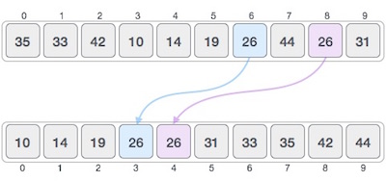

If a sorting algorithm, after sorting the contents, changes the sequence of similar content in which they appear, it is called **unstable sorting**.

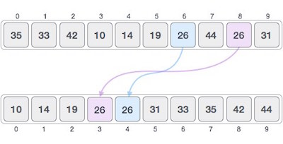

Stability of an algorithm matters when we wish to maintain the sequence of original elements, like in a tuple for example.

Adaptive and Non-Adaptive Sorting Algorithm

A sorting algorithm is said to be adaptive, if it takes advantage of already 'sorted' elements in the list that is to be sorted. That is, while sorting if the source list has some element already sorted, adaptive algorithms will take this into account and will try not to re-order them.

A non-adaptive algorithm is one which does not take into account the elements which are already sorted. They try to force every single element to be re-ordered to confirm their sortedness.

Important Terms

Some terms are generally coined while discussing sorting techniques, here is a brief introduction to them −

### Increasing Order

A sequence of values is said to be in **increasing order**, if the successive element is greater than the previous one. For example, 1, 3, 4, 6, 8, 9 are in increasing order, as every next element is greater than the previous element.

### Decreasing Order

A sequence of values is said to be in **decreasing order**, if the successive element is less than the current one. For example, 9, 8, 6, 4, 3, 1 are in decreasing order, as every next element is less than the previous element.

### Non-Increasing Order

A sequence of values is said to be in **non-increasing order**, if the successive element is less than or equal to its previous element in the sequence. This order occurs when the sequence contains duplicate values. For example, 9, 8, 6, 3, 3, 1 are in non-increasing order, as every next element is less than or equal to (in case of 3) but not greater than any previous element.

### Non-Decreasing Order

A sequence of values is said to be in **non-decreasing order**, if the successive element is greater than or equal to its previous element in the sequence. This order occurs when the sequence contains duplicate values. For example, 1, 3, 3, 6, 8, 9 are in non-decreasing order, as every next element is greater than or equal to (in case of 3) but not less than the previous one.

How Bubble Sort Works?

We take an unsorted array for our example. Bubble sort takes Ο(n2) time so we're keeping it short and precise.

Bubble Sort

Bubble sort starts with very first two elements, comparing them to check which one is greater.

Bubble Sort

In this case, value 33 is greater than 14, so it is already in sorted locations. Next, we compare 33 with 27.

Bubble Sort

We find that 27 is smaller than 33 and these two values must be swapped.

Bubble Sort

The new array should look like this −

Bubble Sort

Next we compare 33 and 35. We find that both are in already sorted positions.

Bubble Sort

Then we move to the next two values, 35 and 10.

Bubble Sort

We know then that 10 is smaller 35. Hence they are not sorted.

Bubble Sort

We swap these values. We find that we have reached the end of the array. After one iteration, the array should look like this −

Bubble Sort

To be precise, we are now showing how an array should look like after each iteration. After the second iteration, it should look like this −

Bubble Sort

Notice that after each iteration, at least one value moves at the end.

Bubble Sort

And when there's no swap required, bubble sorts learns that an array is completely sorted.

Bubble Sort

Now we should look into some practical aspects of bubble sort.

Algorithm

We assume **list** is an array of **n** elements. We further assume that **swap**function swaps the values of the given array elements.

begin BubbleSort(list)

for all elements of list

if list[i] > list[i+1]

swap(list[i], list[i+1])

end if

end for

return list

end BubbleSort

We observe in algorithm that Bubble Sort compares each pair of array element unless the whole array is completely sorted in an ascending order. This may cause a few complexity issues like what if the array needs no more swapping as all the elements are already ascending.

To ease-out the issue, we use one flag variable **swapped** which will help us see if any swap has happened or not. If no swap has occurred, i.e. the array requires no more processing to be sorted, it will come out of the loop.

Pseudocode of BubbleSort algorithm can be written as follows −

procedure bubbleSort( list : array of items )

loop = list.count;

for i = 0 to loop-1 do:

swapped = false

for j = 0 to loop-1 do:

/* compare the adjacent elements */

if list[j] > list[j+1] then

/* swap them */

swap( list[j], list[j+1] )

swapped = true

end if

end for

/*if no number was swapped that means

array is sorted now, break the loop.*/

if(not swapped) then

break

end if

end for

end procedure return list

(tutorialspoint, 2015)

# References:

c4learn. (2013, 1 20). C Array Types. Retrieved 10 15, 2018, from c4learn: http://www.c4learn.com/c-programming/c-array-types/

hackerearth. (2016, 10 1). Breadth First Search. Retrieved 10 28, 2018, from hackerearth: https://www.hackerearth.com/practice/algorithms/graphs/breadth-first-search/tutorial/

Studytonight. (2015, 1 10). C LANGUAGE. Retrieved 10 15, 2018, from Studytonight: https://www.studytonight.com/c/arrays-in-c.php

thecrazyprogrammer. (2015, 6 15). Retrieved 10 28, 2018, from thecrazyprogrammer: https://www.thecrazyprogrammer.com/2014/03/depth-first-search-dfs-traversal-of-a-graph.html

tutorialspoint. (2015, 6 20). Data Structure and Algorithms - Linked List. Retrieved 10 15, 2018, from tutorialspoint: https://www.tutorialspoint.com/data_structures_algorithms/linked_list_algorithms.htm